WEEKLY UPDATE 5th August 2019: Meat Industry Strategic Plan 2030

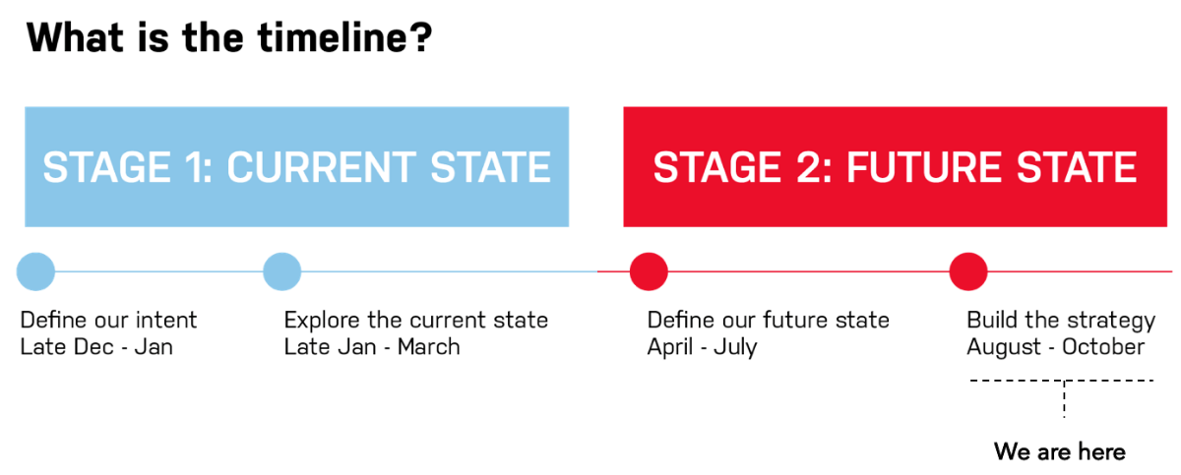

Hi everyone,
Project status
Three workshops were held last week for people who couldn’t attend regional roadshow workshops. These resulted in more good feedback.
That marks the end of public consultation work, with the focus now on drafting the strategy and maintaining Service Provider and Peak Industry Council support to finalise and launch MISP 2030 on October 16. See report here.
As noted last week, the change in focus of the project means we are changing MISP project management at RMAC. Keith Sherringham, who has been instrumental in the development phase, has finished up with RMAC and Tamara Badenoch will now lead the engagement and establishment aspects as the MISP development is wound down and the programs of work are stood up. You can contact Tamara at tamara@rmac.com.au.
Upcoming MISP 2030 priorities
- August CDT meeting (6 Aug) to review further MISP drafting
- Iteration of MISP based on CDT comment
- Development of next MISP iteration for RMAC review
- Preparation for RMAC meeting to review next MISP iteration
- Continued full MISP document drafting
Last week (w/c 29th July)
- Delivery of 3 x webinar events – similar format to regional road-testing
- Collation of outcomes and feedback from regional road-testing events and webinars
- Further review of earlier inputs and analyses to support strategy iteration
- Further refinement and development of strategic framework to enable creation of next version/iteration
- Commence drafting of other MISP document components, e.g. current state
- Development of work plan, timeline and key events and tasks for strategy iteration and finalisation, through to launch
Drafting and Review Schedule
Please be advised in this phase of the key drafting and review dates:
- 5 August – Distribute Draft Strategy + Other Materials to CDT
- 6 August – CDT Review Session
- 9 Aug – Draft 1 released for Board + CEOs
- 13 – 14 August – Board + CEO page turn of Draft 1
- 19 August – 30 August – Next release – RMAC CEOs and Directors will be sharing with their boards and we have various stakeholder engagements locked in over this period.
- 23 August – FYI ONLY: RMAC Internal Planning Day
- 27 August – Distribution of materials for September CDT
- 29 August – FYI ONLY: Joint Partner Communications Planning Day
- 5 September – September CDT
- 9 September – Final Draft released
- 13 September – RMAC CEO and Board Strategy Final Review meeting
- 30 September – Proposed finalisation of Final Draft
- 16 October – Launch
Challenge Question
A key success indicator for MISP 2030 will be the extent to which its programs of work are used and adopted across the industry to keep Aussie red meat businesses successful. What are the most effective ways our industry can work together to drive the grassroots awareness and adoption to achieve this?
As always, if you have any questions, or would like assistance on anything regarding MISP 2030 please let me know.
Have a great week,
