WEEKLY UPDATE: Meat Industry Strategic Plan 2030

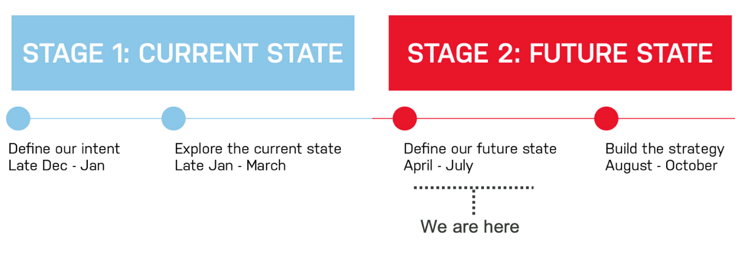Hi everyone,
Project status
The regional roadshows across 6 states have gone well providing good feedback and guidance on implementation and 2030 views from businesses on the ground. The MISP is moving to write up and implementation planning; and a drafting and review schedule is included below out until October. See report here.
The MISP partner CEOs have met and are now considering a cross sectoral transition and governance program for the MISP from October - July and then beyond.
With most of the consultation work now done, the report has detailed more of the completion milestones but is still tracking to same completion dates. There will also be a staffing change reflecting the emerging needs of the project. After getting us to the writing stage, Keith is off to new pastures and finishes up 2 August. He is handing over to Tamara Hager Badenoch week who will lead the engagement and establishment aspects as the MISP development is wound down and the programs of work are stood up. We thank Keith for his excellent contribution in managing and challenging the process, particularly the logistics, strategy development and implementation and wish him well in his next phase.
Webinars
Webinar sessions will be delivered via the FutureBeef platform for people unable to attend regional roadshows. Times and dates are below. Please feel free to attend and contribute, and most importantly plase share with your networks - more information and how to register is here.
- 30-Jul 19:30 – 20:30 EST
- 31-Jul 12:30 – 13:30 EST
- 1-Aug 21:30 – 22:30 EST
Upcoming MISP 2030 priorities
- Collation of outcomes and feedback from regional road-testing events
- Further review of earlier inputs and analyses to support strategy iteration
- Further refinement and development of strategic framework to enable creation of next version/iteration
- Development of work plan, timeline and key events and tasks for strategy iteration and finalisation, through to launch
Last week (w/c 23 July)
- Final regional road-testing events and site visits (Townsville (QLD) – 23rd Jul, Dubbo (NSW) and Longford (TAS) – 25th July)
- Collation of outcomes and feedback from regional road-testing events
- Further strategy drafting - development of draft MISP framework, including review based on regional road-test feedback
- Preparation for 3 x webinar events (30th, 31st July and 1st August)
Challenge Question
If there was one statement that summarised the aspirations of the red meat industry what would it be?
For example: “red meat is the celebration food of choice for the world” or “a healthy world comes from red meat” or “Australia runs better on red meat”.
Please feel free to create and innovate.
As always, if you have any questions, or would like assistance on anything regarding MISP 2030 please let me know.
Have a great week,
