WEEKLY UPDATE 27th August 2019: Meat Industry Strategic Plan 2030

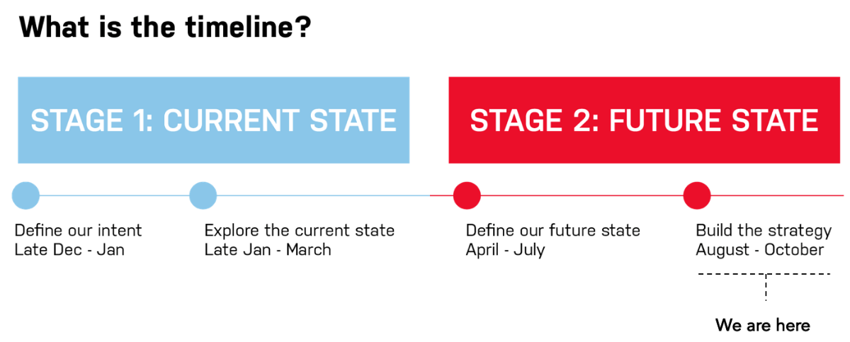

Project status
The draft two of MISP is being reviewed by the Core Design Team, MISP Partner CEOs and RMAC Chairs. A meeting of MISP partner communication managers (29 June 2019) this week will co-design a communication plan to launch MISP 2030 on 16 October and promote awareness during the transition phase to July 2020.
Please contact Tamara Badenoch if you have any questions on the engagement and establishment aspects of MISP 2030 at tamara@rmac.com.au
Upcoming MISP 2030 priorities (w/c 26 August)
- Roundtable discussions with AMIC and GICA boards
- Further review/completion of remaining MISP visuals and text
- Revised MISP draft being reviewed by CDT, MISP CEOs and MISP Chairs
- COB 2 September: Feedback on MISP draft due
Last week (w/c 19th Aug)
- Further iteration of MISP based on RMAC Board/CEO feedback
- Continued full MISP document drafting
- Distribution of next MISP version to CDT, MISP CEOs and MISP Chairs
As always in this drafting phase, if you have any questions, or would like assistance on anything regarding MISP 2030 please let me know.
Have a great week,

