WEEKLY UPDATE 22nd July 2019: Meat Industry Strategic Plan 2030

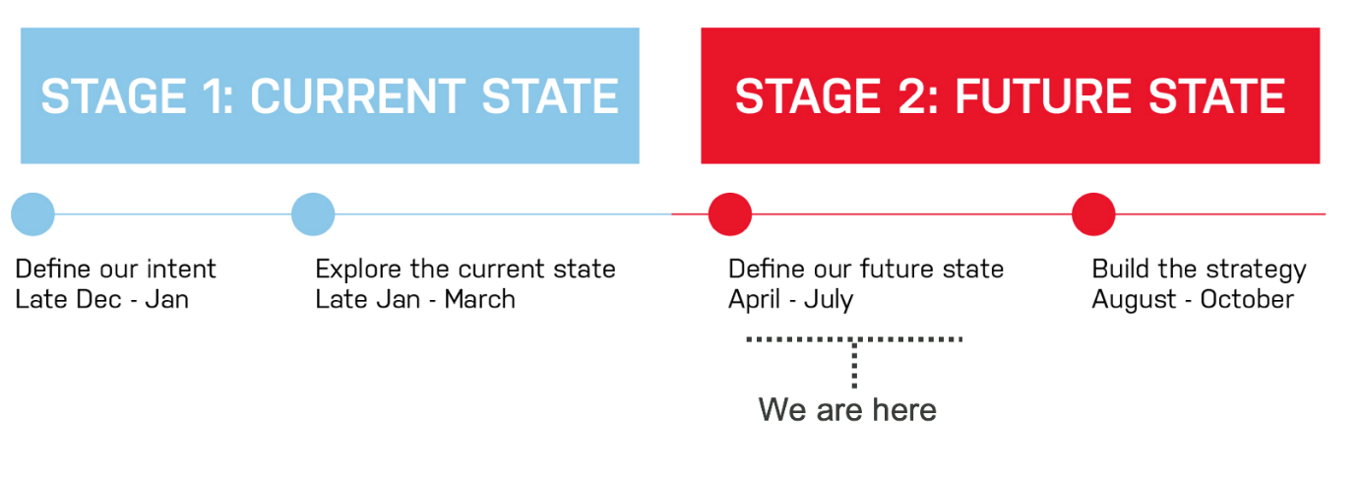Project status
The regional roadshows continue to go well with support for the programs and ideas around implementation and adoption. The focus is moving to writing up and as the revisions proceed, we plan to keep the engagement through weekly updates on themes and program to keep the reviewing and engagement ongoing. Thank you for your ongoing assistance and support. View the updated status report here.
Webinar sessions will be delivered via the FutureBeef platform for people unable to attend regional roadshows. Times (intended to be suitable for stakeholders across Australia) and dates are below. Please share with your networks - more information and how to register is here.
- 30-Jul 19:30 – 20:30 EST
- 31-Jul 12:30 – 13:30 EST
- 1-Aug 21:30 – 22:30 EST
For questions or feedback please contact Project Manager Keith Sherringham at keith@rmac.com.au, 0412 161 870.
Upcoming MISP 2030 priorities
- Final regional road-testing events and site visits: 23rd Jul: Townsville (QLD); 25th July: Dubbo (NSW) and Longford (TAS)
- Collation of outcomes and feedback from regional road-testing events
- Further strategy drafting - development of draft MISP framework, including review based on regional road-test feedback
- Preparation for 3 x webinar events (30th, 31st July and 1stAugust)
Last week (w/c 15 July)
- Regional road-testing events and site visits (Murray Bridge (SA) – 16th Jul, Albany (WA) – 18th July and Perth (WA) – 19th July)
- Collation of outcomes and feedback from regional road-testing events
- Further strategy drafting - development of draft MISP framework, including review based on regional road-test feedback
- Preparation for 3 x webinar events
- Preparation for 3 x regional road-testing events (Townsville (QLD) – 23rd Jul, Dubbo (NSW) and Longford (TAS) – 25th July)
Challenge Question
As the MISP moves into write up and review, what is the one priority you see for each sector:
(i) Grass fed producers
(ii) Grain fed producers
(iii) Sales yards
(iv) Transporters
(v) Processers
(vi) Live Export
(vii) Wholesale
(viii) Retailers
(ix) Food outlets
As always, if you have any questions, or would like assistance on anything regarding MISP 2030 please let me know.
Have a great week,
