WEEKLY UPDATE 19th August 2019: Meat Industry Strategic Plan 2030

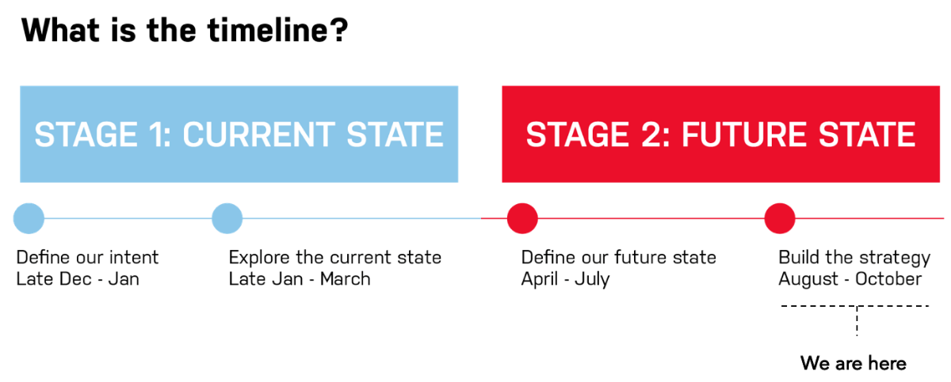

Hi everyone,
Project status
The project team are busy incorporating feedback from an extremely constructive two days working through MISP2030 with RMAC partner CEOs and Chairs. See Full report here.
Please contact Tamara Badenoch if you have any questions on the engagement and establishment aspects of MISP 2030 at tamara@rmac.com.au.
Upcoming MISP 2030 priorities
- 20 August – DA Briefing, Update provided to the Australian Beef Sustainability Framework
- 21 August – High level briefings with ALEC, ALFA and LiveCorp
- Further iteration of MISP based on RMAC Board/CEO feedback, including collating feedback from Cattle Council of Austraila
- Continued full MISP document drafting
- Distribution of next MISP version to CDT, MISP CEOs and MISP Chairs (21 Aug) for feedback by early September
- MISP partners continue to consider a transition, implementation + governance framework using a cross sectoral Taskforce model
Last week (w/c 12th Aug)
- Successful combined RMAC Board/CEO MISP “page turn” meeting (13 - 14 Aug)
- Briefing and feedback received from Cattle Council
- Further iteration of MISP based on RMAC Board/CEO feedback
- Continued full MISP document drafting
Drafting and Review Schedule
Please be advised in this phase of the key drafting and review dates:
- 13 – 14 August – Board + CEO page turn of Draft 1 [COMPLETE]
- 21 August – 30 August – Next release – RMAC CEOs and Directors will be sharing with their boards and we have various stakeholder engagements locked in over this period (nb: revised from 19 August)
- 23 August – FYI ONLY: RMAC Internal Planning Day
- 27 August – Distribution of materials for September CDT
- 29 August – FYI ONLY: Joint Partner Communications Planning Day for launch and transition
- 5 September – September CDT
- 9 September – Final Draft released
- 13 September – RMAC CEO and Board Strategy Final Review meeting
- 30 September – Proposed finalisation of Final Draft
- 16 October – Launch!!!
What we need from you
We are now less than two months out from launch so an all hands on deck is appreciated in providing prompt and meaningful feedback to both the strategy; and the proposed implementation approach.
A big thanks!
Thank you to everyone who has participated to date for their time and expertise and look forward to hearing from you all in this critical project phase.
Have a great week,
