WEEKLY UPDATE 15th July 2019: Meat Industry Strategic Plan 2030

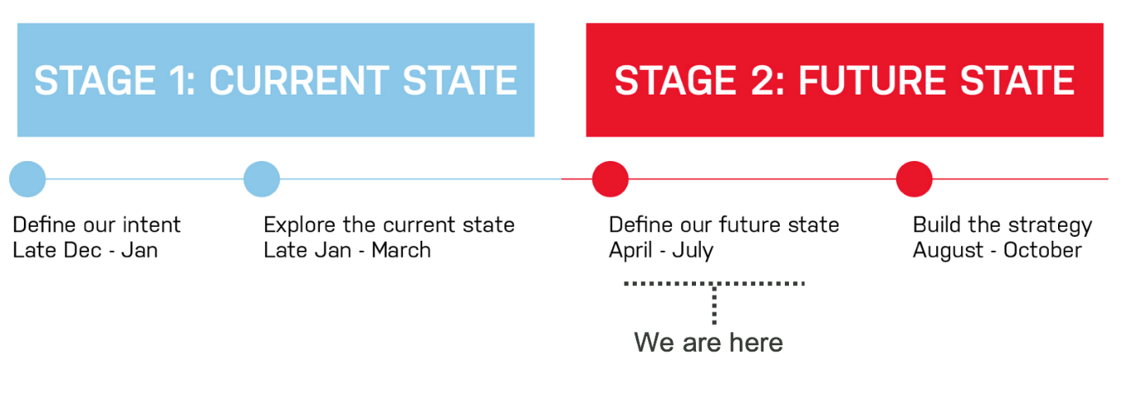Hi everyone,
Project status
Please find here, report for week ending 12-Jul. The regional roadshow and site visit in VIC (Albury) went well with valuable feedback provided. The roadshows bring an important view to the standup and realisation of the programs to support the delivery of the MISP. With a lot of the hard work completed, the process is moving to writing up and development of MISP 2030 with ongoing iterative validation against the feedback from roadshows and the outcomes from the workshops. Your ongoing feedback through the regional roadshows and the online sessions at the end of July is welcome.
Webinar sessions will be delivered via the FutureBeef platform for people unable to attend regional roadshows. Times (intended to be suitable for stakeholders across Australia) and dates are below. Please share with your networks - more information and how to register is here.
- 30-Jul 19:30 – 20:30 EST
- 31-Jul 12:30 – 13:30 EST
- 1-Aug 21:30 – 22:30 EST
For questions or feedback please contact Project Manager Keith Sherringham at keith@rmac.com.au, 0412 161 870.
Upcoming MISP 2030 priorities
- Regional road-testing events, site visits (Murray Bridge – 16th Jul, Albany 18th July and Perth – 19th July)
- Collation of outcomes and feedback from regional road-testing events
- Strategy drafting - development of draft MISP framework
- Preparation for 3 x webinar events
Last week (w/c 8 July)
- Finalisation of regional road-testing materials
- Finalisation of regional road-testing events, site visits and venues
- First regional road-test events held (11th – 12th July, Albury)
- Further development of draft MISP framework following CEO and CDT review
- CDT meeting to discuss draft MISP framework materials
- Circulation of conversation tracker from Toowoomba workshops
Challenge Question
As the programs to deliver the MISP take shape what do you see as the highest priority for these programs over the next 1-2 and 2-4 years?
As always, if you have any questions, or would like assistance on anything regarding MISP 2030 please let me know.
Have a great week,

