WEEKLY UPDATE 12th August 2019: Meat Industry Strategic Plan 2030

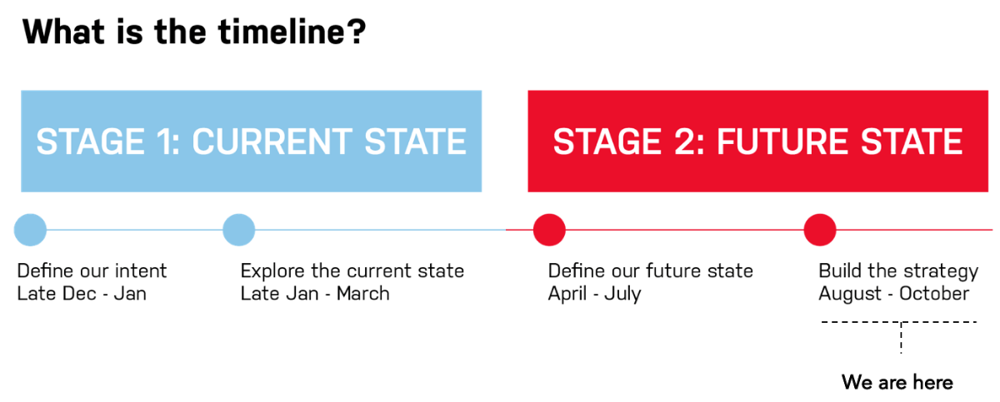

Hi everyone,
Project status
MISP has now completely entered drafting phase in the lead up to October 2019 finalisation. A project report can be found here. This week sees a critical project phase with all MISP partners meeting in Canberra 13 - 14 August.
A reminder that Tamara Badenoch is the key liaison point on this project moving forward and can be contacted on tamara@rmac.com.au.
Last week (w/c 5th Aug)
- August CDT meeting (6 Aug) to review further MISP drafting
- Iteration of MISP based on CDT comment
- Development of next MISP iteration for RMAC review
- Preparation for RMAC meeting to review next MISP iteration
- Continued full MISP document drafting

Next week (w/c 12th Aug)
- Review of next MISP iteration with combined RMAC Board/CEO meeting
- Further iteration of MISP based on RMAC Board/CEO feedback
- Continued full MISP document drafting
Drafting and Review Schedule
Please be advised in this phase of the key drafting and review dates:
- 5 August – Distribute Draft Strategy + Other Materials to CDT [COMPLETE]
- 6 August – CDT Review Session [COMPLETE]
- 9 Aug – Draft 1 released for Board + CEOs [COMPLETE]
- 13 – 14 August – Board + CEO page turn of Draft 1
- 19 August – 30 August – Next release – RMAC CEOs and Directors will be sharing with their boards and we have various stakeholder engagements locked in over this period.
- 23 August – FYI ONLY: RMAC Internal Planning Day
- 27 August – Distribution of materials for September CDT
- 29 August – FYI ONLY: Joint Partner Communications Planning Day
- 5 September – September CDT
- 9 September – Final Draft released
- 13 September – RMAC CEO and Board Strategy Final Review meeting
- 30 September – Proposed finalisation of Final Draft
- 16 October – Launch
This week will be a very busy one for RMAC so your patience as ever appreciated in receiving a response!
Kind Regards,

